Core|WFM: Time Management

Contents
Document Version Control 1
Approved process for raising 2
Consultation & Approval 2
Change Management 2
How to 3
Testing 5
Communications 5
Downstream Systems & Processes 5
Affected Reports 5
Additional Background Information 6

Document Version Control
Change History/Review Details
Date | Version | Review by | Summary of Change
Mar22 | 1.0 | HC | Created

Approved process for raising
Does the change need to be raised through a particular route or by a particular person/team? Are there any actions which need to be taken or considered prior to processing in the HRIS Support Centre?
A request for change could come from any source and is most likely to be a business requirement due to changes in existing process or implementation of new processes.
Alternatively it could be a fix or enhancement that has been provided by the supplier.
Any changes to any area of the Portal must follow the Change Management process in force at the time of the change.
Changes may need to be presented at HRSEG for agreement before being implemented and possibly shared with the CoreTime POG.

Consultation & Approval
Who is the owner of this information? Who needs to be consulted about this change before you begin work on it? Does anyone need to approve this change before it is implemented?
Changes may need to be presented at HRSEG for agreement before being implemented and possibly shared with the CoreTime POG.
A change may need payroll approval if it relates to Timesheets.

Change Management
What type of change is this? When should approval be sought and from whom (internal to team or change manager)? Who would normally be responsible for implementing?
The system changes must be approved by the System Owner (the Head HR Systems) or their nominated deputy, via the change request in OSM, ideally before implementation

How to
Technically how to process the change in the system
Adding a new ….
CoreTime|CoreRoster > System Parameters > Balances

As there are multiple steps required for creating a balance please refer to the HOW TO guide - HOW TO - Manage Balances in CoreTime HC DRAFT.docx

Changing a ….
CoreTime|CoreRoster > System Parameters > Balances

As there are multiple areas that can be edited within a balance please refer to the HOW TO guide - HOW TO - Manage Balances in CoreTime HC DRAFT.docx

Removing a ….
Standard Icons & Terminology
Standard Button Names  Enter Query Mode button:  Previous Record button:   Previous Section button:   Save button:   Insert Record button:  | Execute Query button:   Next Record button:   Next Section button:   LOV button:   Delete Record button:  | Cancel Query button:   Red Door button:   Duplicate Record button: 
Navigation Paths
Show the final navigation path option in bold+italics, for example;
Core|Personnel > Reference > Reference A – C > Accident Codes
Core|Pay > Reference > Pay Groups
Any further navigation beyond the navigation path can be added after an ellipsis (…), for example;
Event Management > Event Configuration … HR Events > Change of Address
Other Standard Terminology

Testing
Who would normally be responsible for testing? Are there standard items to test?
The Functional Analyst team will usually be responsible for testing any changes.
The changes should be made in a suitable test environment and may need to be tested for different user access roles depending upon the nature of the change. For example changes made to items accessed by departmental users should be tested using the relevant menu profile(s) assigned to those users

Communications
Who needs to be informed (but not consulted) about this change? Detail when they should be informed (before or after the change).
Departmental users should be informed about changes via the HRIS bulletin, ideally before the changes are made.
HR Systems support should be informed when the changes are made.
Business Change and Training will need to be informed before the change is made as guidance and web pages may need to be updated and we may wish to send communications to employees if the change directly affects them.

Downstream Systems & Processes
Details of any processes which are affected or need to be carried out following, or as part of, the change. Please detail any triggers, actions required and when the actions should be carried out.
Payroll may be affected by changes to Timesheets. Any changes should be discussed with the Payroll Manager in advance.
ESS and MSS – certain changes will affect these areas

Affected Reports
Are there any standard reports which may need to be updated following this change?
Check whether any of the following reports are affected by the change:
TIMDEP01 – Timesheet approvals
TIMDEP02 – Annual Leave
TIMDEP03 – Sickness absence

Additional Background Information
Any other relevant information, links to supporting documentation etc.
Link to Balance decision tree.

HOW TO – Manage Balances in CoreTime
HOW TO – Maintain Pay Codes for Time Management
HOW TO – Update Holiday Schemes

Balances Overview
Within Time Management each appointment requires an associated Balance which determines how the annual leave for the appointment will be calculated. The Balance can draw on a range of parameters, dependent on the settings, including: Holiday Schemes, Long Service Schemes, timesheet hours and the current appointment.
Departments are responsible for assigning the appropriate Balance to each appointment via People Management, but cannot view the underlying Balance settings. It is therefore important that the Balances are correctly configured and appropriately named, so that HR administrators can easily identify the correct option and audit their appointments for errors.
Before further balances are created, it is recommended that the new setting providing the option to connect the balance to the appointment FTE Hours is explored. If Balances no longer need to be specific to appointments sharing the same FTE Hours value, the total number of Balances could be significantly reduced and HR Admins would be able to apply the same Balance to support staff and academic-related staff.

New Balance Settings = Advanced parameters > Company Holiday Entitlement
Fields: Link ‘Default Hours to Personnel’ & ‘Personnel Default Hours Divisor

Tweaking of the Entitlements per Balance is also required when these settings are in use, so that one Balance can be linked to multiple Long Service Schemes.

Identifying when a new Balance is required
To reduce the risk of departments assigning the wrong Balance and to minimise the central overhead of maintaining PeopleXD-Time, new Balances (and any associated config items) should only be created when necessary.
To determine if a new Balance and/or associated config items are required, follow the Balance decision tree.
Before creating a new Balance, assess the net benefits. Is the balance likely to be required long-term and used by multiple employees and does it warrant the additional maintenance overhead or complexity? Some exceptions may be better suited to management by departmental HR through manual balance adjustments.
If bespoke Balances or Holiday Schemes covering only a small number of appointments are frequently requested, it may become necessary to apply some sort of threshold. Similarly, if a department has inconsistent or unpredictable closure patterns, it may benefit Departmental HR to adopt a self-book approach to closure days (Balances with no Holiday Scheme)

Accrual Balances - Background
It is anticipated that the two Accrual Balances set up during the initial configuration, codes CASUAL and VARI will be appropriate for all use by all University departments. New Accrual Balances should only be required when expanding use of People XD time to new staff types, such as TSS workers.
Accrual Balances are not linked with Holiday Schemes and the calculations are not impacted by the appointment FTE hours setting, so the key factors to consider are:

- The rate (%) at which holiday is accrued
- Whether this rate is impacted by long service
- The type of leave year followed (a personal leave year or a universal leave year), and where a universal leave year is followed, the leave year start/end dates
- The Holiday Pay Code(s) which will affect the balance

Only Accrual Balances which follow a universal leave year can be linked to a Long Service Scheme, but the Long Service Scheme must be specifically configured for use with an Accrual Balance (do not link to the Long Service schemes configured for Entitlement Balances)

Universal leave year Vs Personal leave year
Accrual Balances can be configured in two ways to cater for the common annual leave arrangements used by paid as claimed-style appointments:

Universal leave year – linked to a set leave year, such as the University standard leave year which runs 1st October – 30th September.
Personal Leave Year – Leave year determined per appointment, e.g. using the appointment start date as the leave year start.

Accrual Balances & Pay Codes
Leave which is accrued is managed through timesheets. For the balance to function correctly and to allow staff to record leave taken, Pay Codes need to be correctly configured. Unlike Entitlement Balances, which share pay codes, it is likely each Accrual Balance will require its own set of Pay Codes including:
- At least one Accrual Pay Code which accrues leave e.g. 107 PAID AS CLAIMED PAYMENT
- At least one Holiday Pay Code which records leave taken e.g. 4231 CAS HOLIDAY PAY (HRS)
Pay Codes should be created before attempting to configure an Accrual Balance. Bespoke Pay Code Access Groups will be required to enable the appropriate staff to record time against these pay codes.

Long Service Scheme (for Accrual Balances)
A Long Service Scheme can be linked to an Accrual Balance, but this is optional and Accrual Balances will function without a scheme.
Long Service schemes should only be linked to Accrual Balances that follow a universal leave year, they cannot not be used with Accrual Balances that follow a personal calendar.

Entitlement Balances - Background
An entitlement Balance provides the employee with an annual leave allowance to use during their leave year. The amount of entitlement the system issues is calculated by drawing on several factors: the settings within the Balance itself, certain appointment settings and where applicable, the associated configuration items (e.g. Holiday Scheme).

The appointment settings impacting the entitlement are:
- Contracted hours/multiplier – part-timers get a pro rata entitlement
- Start /end date – e.g. those starting mid leave year get a pro rata entitlement
- Continuous service start date – factored into the long service entitlement (if applicable)

Balances are assigned in days for full time staff and hours for part time staff. In this context full time staff means staff who work the standard days every week, according to their grade e.g. 7.5 hours per day for Grade 6 and above. If an employee works different hours each day then the annual leave balance should be assigned in hours. In this scenario public holidays and fixed closure days will be assigned the actual hours due to be worked on those days.

Most balance settings will be the same across all entitlement Balances, the settings which differ are:
- The FTE Hours - the default weekly hours, e.g. 37.5 for academic related (May not be applicable if the ‘Link Default Hours to Personnel’ setting is in use)
- Base Entitlement – for a full time staff member before any pro rata calculations or long service days, e.g. 38 days or equivalent in hours
- The leave year start and end dates – e.g. running 1st Oct-30th Sept

The associated items affecting the entitlement (where applicable) are:
- Holiday Schemes
- Long Service Schemes

Follow the New Balance Decision Tree to determine when a new Balance is required, and when it can be linked to existing Holiday and Long Service schemes.

Standard University Annual Leave Entitlement
It is expected that most appointments will follow the standard University leave arrangements. I.e. A base entitlement of 38 days’ leave pro rata and a leave year running 1st Oct - 30th Sept.

Preparation
Before you begin creating a Balance, ensure you have determined:
- A name for the balance (see relevant section for guidance)
- The baseline entitlement, e.g. 38 days pro rata
- The holiday year start/end dates
- The full-time equivalent hours (FTE hours), e.g. 37.5 hours for Grade 6+
Plus, where applicable:
- The Holiday Scheme the Balance will follow, or where a new scheme is required, the precise list of closure dates (public holidays and fixed closure days)
- The Long Service Scheme, or where a new scheme is required, the rules of the scheme

Long Service Increments
Each increment represents a stage in the long service scheme. The value recorded in the ‘Floating Entitlement’ column is the number of additional days that will automatically awarded at that stage, based on that employee’s length of service. The days are cumulative, so each increment only needs to display the number of additional days awarded at that stage.
By default, the leave is awarded at the start of the leave year during which the employee crosses the threshold (anniversary year). To award the additional leave at the start of the following leave year, you need to increase the months by 12.

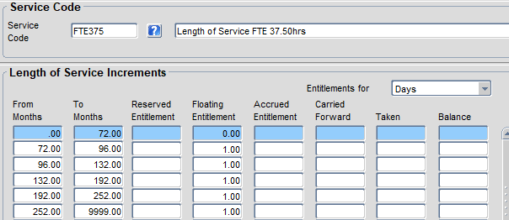

In the above example, an employee is entitled to an additional day of leave at the start of the leave year following their 5th anniversary.
The system would not award any additional leave until the start of the leave year during which the employee’s continuous service is scheduled to exceed 72 months (6 years).

Balance calendar
Each Balance has its own Balance Calendar, which determines the start and end dates of the leave year (periods), and the rules for carrying forward leave from one leave year to the next.

These must be extended each year to cover the next calendar year. For example, if Annual Leave is managed in yearly blocks the Annual Leave balance calendar defines the start date and end date of each leave year (period) and specifies any carry forward rules. It is not possible to close a balance period (complete a period end) until the next period has been configured on the balance calendar.
You may find it useful to refer to the guides - HOW TO - Update Holiday Schemes v1.1.docx and HOW TO – Maintain calendars in WFM

Balance entitlements
Each Balance needs its own set of Balance Entitlements. The Balance Entitlements determine amount of annual leave that a full-time employee receives to take on dates of their choosing (Personal Leave). In PeopleXD, this is categorised as Floating leave. For every leave year (period) a Balance Entitlement must be set.

Calculating Floating leave days/hours
If a Holiday Scheme has been linked to the Balance, the Balance entitlement must offset the number of closure days in the Holiday Scheme. The number of closure dates can vary year on year, so the floating leave values may need to fluctuate to reflect these changes. To determine the number of floating days needed in any specific year, use the following formula:
Floating days + Closure days = Base entitlement

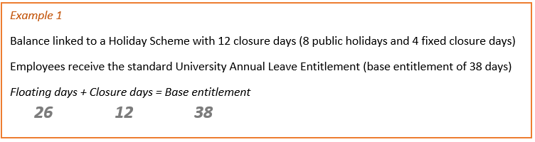
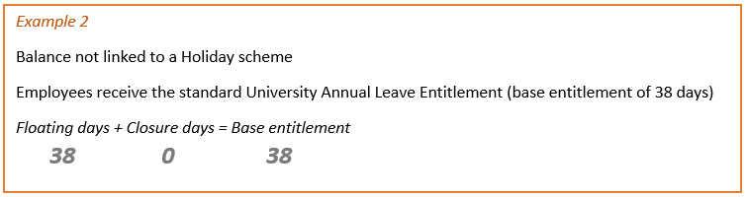
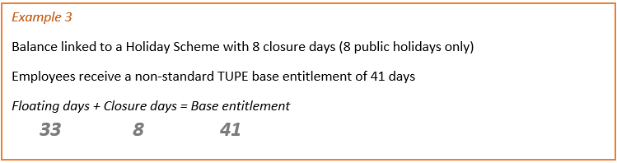

Note: If the Holiday Scheme includes closure day(s) which are awarded on top of the base entitlement, such as discretionary additional leave days awarded by the VC in certain years, and you do not want these days to reduce the amount of Personal Leave the employee has, ensure you either increase the base entitlement value (e.g. to 39) or ignore the leave in the closure days value

